# Python Environment Setup

### Installing Anaconda

If you are new to Python, we recommend that you install Anaconda. Anaconda easily installs Python and the Jupyter Notebook that you will need to complete your assignments. Please go to the following website and follow Anaconda’s instructions to download and install Python 2.7 or Python 3.5:

<https://www.continuum.io/downloads>

### Running Juptyter Notebook

After downloading the Anaconda Cloud, you can run the Jupyter notebook. To start the notebook server from the command line (CMD prompt on Windows, Terminal on Mac/Linux), use the following command:

jupyter notebook

This prints some information in your terminal about the notebook server, which includes the web application’s URL (Default: <http://127.0.0.1:8888>). It will then visit this URL through your default web browser.

The notebook opens up to its dashboard page, which displays a list of files, notebooks, and subdirectories stored in the directory where the notebook server was started.

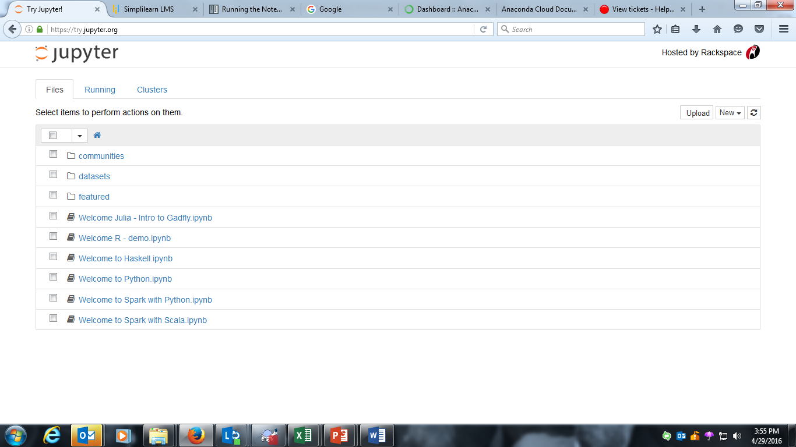

You may prefer to start a notebook server in the topmost directory where your notebooks would be easily accessible. Usually, this would be your home directory.

### Additional Options

The notebook server starts on port 8888 by default. If it is unavailable, then the notebook server looks for the next available port.

To specify a port manually, use the following command:

jupyter notebook --port 9999

To start a notebook server without opening a web browser:

jupyter notebook --no-browser

To view other command line arguments of the notebook server, use the –help flag:

jupyter notebook --help